**Type 2 Liverpool Ringing Simulator**

03 – Configuring Abel Guide

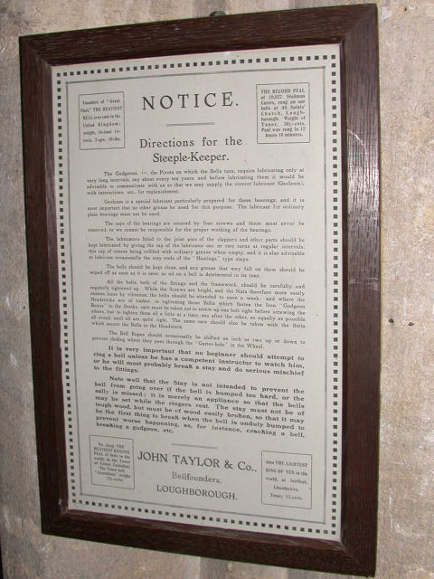

Author: Andrew Instone-Cowie

Date: 19 June 2024

Version: 1.3

Contents

Index of Figures 2

Document History 4

Licence 4

Documentation Map 5

About This Guide 6

First Steps 6

Next Steps 6

Abel Copyright & Licensing 7

External Bells Configuration 7

Auto-Configuration 11

Restrictions 12

Ringing Subsets of Bells 13

Ringing the Light Bells 13

Ringing the Back Bells 13

Moving Ringers 15

Delay Timer Calibration 17

Using Multiple PCs 18

Second PC Module & Basic Serial Splitter Module 18

Configuring the Interface 18

# Index of Figures

Figure 1 – Documentation Map 5

Figure 2 – Abel – Discover Ports 7

Figure 3 – Abel – Port Discovery 8

Figure 4 – Abel – Port Setting 8

Figure 5 – Abel – Signal Setting 9

Figure 6 – Abel – Mappings 9

Figure 7 – Abel – Sensor Delays 10

Figure 8 – Abel – Discover Ports 11

Figure 9 – Abel – Auto-Configuration Port Discovery 11

Figure 10 – Abel – Auto-Configured Port Settings 12

Figure 11 – Abel – External Bells Dialogue (Back 8) 14

Figure 12 – Windows Shortcut Creation Dialogue 14

Figure 13 – Abel – Key Starts Bell Movement 15

Figure 14 – Abel – User Bell Movement 16

Figure 15 – Abel – Striking Controls 18

# Document History

|  |  |  |  |
| --- | --- | --- | --- |
| **Version** | **Author** | **Date** | **Changes** |
| 0.1 | A J Instone-Cowie | 10/09/2018 | First Draft. |
| 1.0 | A J Instone-Cowie | 03/08/2019 | First Release. |
| 1.1 | A J Instone-Cowie | 01/10/2019 | Multi-PC Options. |
| 1.2 | A J Instone-Cowie | 18/08/2020 | Minor update. |
| 1.3 | A J Instone-Cowie | 19/06/2024 | Update for Abel 10.3.2 and auto-configuration. Update external links. |

*Copyright ©2018-24 Andrew Instone-Cowie.*

*Cover photograph: “Directions for the Steeple-Keeper”. © 2008 Keith Edkins*

*[CC BY-SA 2.0 (<https://creativecommons.org/licenses/by-sa/2.0>)], via Wikimedia Commons*

# Licence

**

*This work is licensed under a Creative Commons Attribution-ShareAlike 4.0 International License.[1]*

*Unless otherwise separately undertaken by the Licensor, to the extent possible, the Licensor offers the Licensed Material as-is and as-available, and makes no representations or warranties of any kind concerning the Licensed Material, whether express, implied, statutory, or other. This includes, without limitation, warranties of title, merchantability, fitness for a particular purpose, non-infringement, absence of latent or other defects, accuracy, or the presence or absence of errors, whether or not known or discoverable. Where disclaimers of warranties are not allowed in full or in part, this disclaimer may not apply to You.*

*To the extent possible, in no event will the Licensor be liable to You on any legal theory (including, without limitation, negligence) or otherwise for any direct, special, indirect, incidental, consequential, punitive, exemplary, or other losses, costs, expenses, or damages arising out of this Public License or use of the Licensed Material, even if the Licensor has been advised of the possibility of such losses, costs, expenses, or damages. Where a limitation of liability is not allowed in full or in part, this limitation may not apply to You.*

# Documentation Map

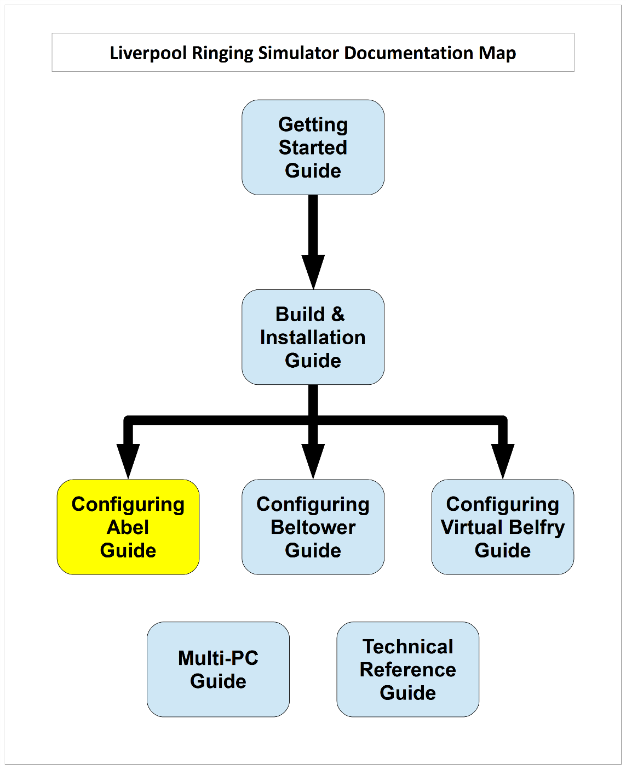

Figure 1 – Documentation Map

# About This Guide

The Type 2 Liverpool Ringing Simulator allows sensors, attached to one or more real tower bells or teaching dumb bells, to be connected to a computer Simulator Software Package such as Abel[2], Beltower[3] or Virtual Belfry[4]. This allows you to extend and augment the teaching and practice opportunities in your tower.

This brief ***Configuring Abel Guide*** shows you how to configure the Abel Simulator Software Package to work with the Type 2 Liverpool Ringing Simulator.

Other project guides are available for the Beltower and Virtual Belfry packages.

## First Steps

This guide begins from the point that you have completed building and installing your Type 2 Liverpool Simulator hardware, and are now ready to configure Abel to work with the simulator.

For guidance on building and installing the Type 2 Liverpool Simulator, please refer to the ***Build & Installation Guide***. For detailed technical information, see also the ***Technical Reference Guide***.

If you want to use multiple PCs concurrently, please refer the ***Multi-PC Guide*** for information on building either the Second PC module or the Basic Serial Splitter module. The Second PC module allows two PCs to be used concurrently, the Basic Serial Splitter up to a maximum of 16.

## Next Steps

This is not a detailed guide to using Abel. Please refer to the Abel documentation and help for more information on the usage and configuration of the application.

This is also not a guide to using a simulator in teaching and practice. For guidance in this area the ART[5] publication ***Teaching with Simulators*** is recommended, available from the ART shop[6].

# Abel Copyright & Licensing

Abel is a copyright software product ©AbelSim Ltd, made available under the Abel End User Licence[7].

All AbelSim profits go to charities, including ringing-related charities. Please ensure your copy of Abel is properly licensed.

Abel can be ordered and downloaded from <https://www.abelsim.co.uk/>.

# External Bells Configuration

Configuration of the Abel Simulator Software Package to use the Simulator Interface should only need to be done once. All settings are saved in the Abel options file. These examples are based on Abel 10.3.2 on Windows 10, screens and options may differ slightly in other versions.

To configure Abel to use the simulator hardware, carry out the following steps. This guide described the minimum necessary to configure Abel to use the simulator hardware, for full details on the overall configuration and features of Abel please refer to the product documentation.

(For information on using the auto-configuration feature introduced in Abel 10.3.2, please refer to the next section of this guide.)

* Start Abel on the Simulator PC, and from the *Options* menu select *External Bells…* .
* In the *External Bells* configuration window, click the *Discover Ports* button.

Figure 2 – Abel – Discover Ports

* Verify that the serial port used by the Simulator Interface is recognised by Abel, and then click *OK*. Note that Abel requires the serial COM port number to be between 1 and 8. Refer to the ***Technical Reference Guide*** for instructions on reconfiguring port numbers.

Figure 3 – Abel – Port Discovery

* Set the *Port* field to the COM port number of the serial interface to be used. In this example the port *COM1* is used. This field should be set to the same value for all sensors connected to the same Simulator Interface.

Figure 4 – Abel – Port Setting

* Set the *Signal* field to *Data*, indicating that this external bell is connected via a Simulator Interface using the MBI data protocol. Do this for all Simulator Sensors connected to a Simulator Interface[8].

Figure 5 – Abel – Signal Setting

* Set the *Map To* fields to map Bell 1 to 1, 2 to 2 and so on, for as many Sensor Heads are connected to the Simulator Interface. This does not mean that Sensor Head number 1 will always the simulated Treble (and so on); the use of the simulated bells can be changed in the main Abel screen – refer to the Abel documentation.

Figure 6 – Abel – Mappings

* Leave the *Control* set to *Ring on 1 of 1*, the de-bounce value at 20ms, and the *Sensors Active-High* box ticked.
* Click on the *Sensor Delays…* button to configure the delay timers.

Figure 7 – Abel – Sensor Delays

* In the *Sensor Delays* window, set the delay for each bell to an appropriate value, so that the simulated bell sounds as closely as possible to the same time as the real bell (this is best done with the real bell un-silenced). Refer to the notes on Delay Time Calibration later in this guide, and note that in Abel the delay values are specified in 1/100ths of a second (centiseconds), not milliseconds
* Make sure the *Abel Applies Delays (no MBI)* box is ticked[9]. Click *Apply* to save the values, and then click *OK*.
* Click *OK* in the *External Bells* window to close it.
* Save the new options by selecting *Save Options* from the *Options* menu. If the options have changed, Abel will prompt for this when the program is closed.
* Abel should now be configured to use the Simulator Interface. Test each bell in turn and check that the simulated bells are correctly mapped to the real bells.

# Auto-Configuration

Abel version 10.3.2 introduced a basic auto-configuration feature for sensors connected via a Simulator Interface. To use this with the Liverpool Ringing Simulator Type 2 Simulator Interface, the interface must be running firmware version 3.7 or later.

* Connect the Simulator Interface to an available serial port on the Simulator PC, as described in the ***Build & Installation Guide***, and turn on the power to the interface.
* Start Abel on the Simulator PC, and from the *Options* menu select *External Bells…* .
* In the *External Bells* configuration window, click the *Discover Ports* button.

Figure 8 – Abel – Discover Ports

* Abel will attempt to detect the Simulator Interface, and offer to configure Abel to use it. Click *Yes* to automatically configure the External Bells settings.

Figure 9 – Abel – Auto-Configuration Port Discovery

* Abel will automatically configure the *Port* field to the COM port number of the serial interface on which the Simulator Interface is detected, configure all the *Signal* fields to *Data*, and configure a standard set of *Map To* values for all bells.

Figure 10 – Abel – Auto-Configured Port Settings

* Customise the auto-configured mappings as required, then click the *Sensor Delays…* button and continue to configure the *Sensor Delays* window as described in the previous section, making sure in particular that the *Abel Applies Delays (no MBI)* box is ticked.

## Restrictions

The following restrictions apply to the Abel auto-configuration functionality:

* Auto-configuration requires at least Abel version 10.3.2. It was not available in previous versions.
* Support for auto-configuration requires at least version 3.7 of the Type 2 Simulator Interface firmware. Update the interface firmware as described in the ***Build & Installation Guide*** to use this feature.
* Auto-configuration is not available if more than one powered on Simulator Interface is connected the Simulator PC. Manual configuration is still possible.
* Auto-configuration is not attempted on any serial port already configured in the *External Bells* window. Manual configuration is still possible.

# Ringing Subsets of Bells

Where simulator sensors are installed on a complete ring of bells, it may be desired to ring a subset of bells, for example the front 6 of a heavy 8, the front 8 of a ring of 12, or the back 8 or 10 of a ring of 12. The following examples show how this may be done using Abel.

## Ringing the Light Bells

Sensors Heads should be connected with the treble mapped as Bell 1 in the Simulator Interface settings, and then the other bells sequentially down to the tenor, as described in the ***Build & Installation Guide***.

Abel does not require sensors installed on additional accidentals such as Sharp 2nd or Flat 6th bells. However, when Abel is configured as above to simulate, say, 12 bells, simply ringing the front 8 bells will sound out of key.

* To ring, for example, the front 8 of a 12 (with 2J bell) and have them sound in key, it is necessary to change the configuration of Abel. Loading one of the 8-bell or 7-bell method files (*8bell.mcf/7bell.mcf*) from the *File | Open…* menu will cause Abel automatically to shift the sound options to a ring of 8 in the correct key, starting from the treble, and automatically adjusting the 2nd up a semitone[10].
* Likewise, loading a 6-bell or 5-bell method file (6*bell.mcf/5bell.mcf*) from the *File | Open…* menu will cause Abel to shift the tuning to a true light 6, starting from the treble.
* Reloading one the 12-bell or 11-bell method files (*12bell.mcf/11bell.mcf*) restores the tuning to a ring of 12 in the correct key.

## Ringing the Back Bells

To ring, for example, the back 8 or back 10 of a ring of 12 for silent practice (where all bells are being rung by ringers and not simulated by the Simulator), is straightforward, and requires only that the simulator is set up as above for 12-bell ringing. No special Abel setup is required.

Ringing the back 8 or back 10 with a mix of real and simulated ringers is more complicated, because Abel will always try to assign bell sensors from Bell 1 upwards. Hence loading the 7- or 8-bell method files causes Abel to switch to the front 8 bells, as noted above, not the back 8, and loading the a 9- or 10-bell method files causes it to attempt to switch to the front 10.

To work around this problem, set Abel up as a ring of 8 or 10, and save the configuration in a new options file by selecting *Save Options As…* from the *Options* menu. It will be necessary to change the mappings in the *External Bells* window to map the Sensor Heads for the real back bells to simulated bells 1 to 8 or 1 to 10.

A similar approach may be used to create configuration options files for the back 10 of a ring of 12, or the back 6 of a ring of 8, and so on, where a mix of real and simulated ringers is required.

The following screenshot illustrates an *External Bells* mapping for the back 8 of a ring of 12. These settings can be saved in a custom Abel Options file.

Figure 11 – Abel – External Bells Dialogue (Back 8)

The custom configuration can then be loaded by selecting *Open Options File…* from the *Options* menu, or by specifying it as a command line option to a desktop shortcut.

Figure 12 – Windows Shortcut Creation Dialogue

(The *Target* field in this example reads in full, *C:\Program Files (x86)\Abel 3\Abel3.exe” /o options\LivCathBack8.opf methods\8bell.mcf*)[11]

# Moving Ringers

If you use the “moving ringers” feature of Abel with the simulator, there are two Abel settings which should be turned off.

* Select moving ringers in the *Options* menu, then in the *Ringing* menu make sure that *Key Starts Bell Movement* is not ticked[12]. Ticking this option will cause the animation and striking of bells rung by real ringers to be out of sync with the simulated moving ringers.

Figure 13 – Abel – Key Starts Bell Movement

* The animation of moving ringer images for bells rung by real ringers can be distracting, particularly as the animation does not move smoothly for these bells. In the *View* menu make sure that *User Bell Movement* is not ticked. This stops the animation for these bells and fades the image of the ringer on the screen.

Figure 14 – Abel – User Bell Movement

# Delay Timer Calibration

For accurate simulation of the real bells, the simulator requires that the delay timer for each bell is set so that the delay applied after Simulator Interface sends the strike signal to the Simulator (at exactly the point at which the real bell passes through bottom dead centre of its swing) results in the simulator sounding at the same time that the open bell would have struck. This delay time is specific to each bell, but for most bells is somewhere around 0.5s (or 50 centiseconds).

The simplest method of setting the timer values is to ring each bell open alongside the simulator.

* Start Abel on the Simulator PC.
* Ring each bell in turn, open, and compare the sound of the bell and the simulated sound from the simulator.
* If the real bell sounds before the simulator, reduce that bell’s delay timer value.
* If the simulator sounds before the real bell, increase that bell’s delay timer value.
* Repeat this process until the sound of the real bell and the sound from the simulator are as close to coincident as possible.
* Repeat for each of the other bells in turn.

Tip: A useful starting point for delay timer values is to measure the period of oscillation of the bell for small swings and set the timer to ¼ of that value. Then fine tune the value as described above.

# Using Multiple PCs

If you want to use multiple PCs concurrently, please refer the ***Multi-PC Guide*** for information on building either the Second PC module or the Basic Serial Splitter module. The Second PC module allows two PCs to be used concurrently, the Basic Serial Splitter up to a maximum of 16.

A Multi-PC configuration typically allows more than one ringer (with headphones) to use the simulator with a simulated band at the same time, each ringing a different physical bell.

## Second PC Module & Basic Serial Splitter Module

From the point of view of Abel, all PCs connected using either the Second PC module or the Basic Serial Splitter module behave in a similar manner. All PCs receive all the sensor signals from the Simulator Interface module, all the time.

Each copy of Abel must be configured to respond to the desired bell or bells and filter out the unwanted signals. This can be done either by using a different *External Bells Configuration* on each PC (these can be saved in multiple Options files), or “on the fly” by un-checking the *Ext Bell* setting in the *Striking Controls* dialogue box for each bell, which can be accessed by right-clicking the bell in the main window.

Figure 15 – Abel – Striking Controls

## Configuring the Interface

When multiple PCs are connected, only one PC can be used to configure the Simulator Interface using a terminal emulator (as described in the ***Build & Installation Guide*** and the ***Multi-PC Guide***).

The PC used for Interface configuration depends on the hardware in use. This is covered in the ***Multi-PC Guide***.

Note that only the PC used for Interface configuration will work with the Abel auto-configuration feature introduced in Abel 10.3.2.

1. <https://creativecommons.org/licenses/by-sa/4.0/>
2. <https://www.abelsim.co.uk/>
3. <https://www.beltower.co.uk/>
4. <https://www.belfryware.com/>
5. Association of Ringing Teachers
6. <https://shop.bellringing.org/>
7. <https://www.abelsim.co.uk/doc/welcome1.htm>
8. It is possible to use more than one Simulator Interface, on different COM ports, on the same Simulator PC.
9. This is the opposite of the setting for the original Type 1 Liverpool Simulator.
10. One consequence of this behaviour is that it is quite possible to ring subsets of bells correctly in key on the simulator, which would not be possible on the real bells; for example the front 10 of a ring of 12, or the front 6 of a ring of 8.
11. On older 32-bit versions of Windows, the application paths will be *C:\Program Files\Abel 3\Abel3.exe*.
12. In previous versions of Abel this option was named *User Starts Bell Movement*.